Car Genesis
Joe Haskins
Mike Holly
Bill Nolin
Simon Wong

Contents
I. Game Mechanics 4
A. Overview 4
B. Camera Position 4
C. User Interface Design 4
1. User Interface Description 4
2. Key Screen Images 5
D. Control Summary 6
1. Keyboard 6
2. Mouse 7
3. Joystick 7
4. Racing Wheel & Pedals 7
5. Game Controller 7
6. Other 7
E. Replaying and Saving 7
F. Level Summary 8
1. Desert Race 8
2. Dusk Race 8
3. Motor Fairway 8
II. Artificial Intelligence 8
A. Opponent AI 8
B. Player Detection 8
C. Motion 8
D. Collisions 8
E. Combat 8
III. Game Elements 9
A. Items 9
1. Car Base 9
2. Body Parts 9
3. Wheels 9
B. Character Bible 9
1. Driver 9
IV. Story Overview 9
A. Background/Plot Summary 9
V. Game Progression 9
A. Setting 9
B. Flowchart 10
C. Level and Scene Details 11
1. Desert Race 11
2. Dusk Race 12
3. Motor Fairway 13
VI. Bibliography 13
A. Both Versions 13
B. High detail version 14

- Game Mechanics
  - Overview
Car genesis was created to allow players to immerse themselves as a driver of vehicles of varying performance. Players can mix and match car pieces and evolve their vehicle by testing on one of the race tracks. Supporting multi-player, Car Genesis allows players to interact on the race track and test their vehicle against other opponents.
  - Camera Position
The player will be able to toggle between first and third person views using the “tab” key.
  - User Interface Design
    - User Interface Description
      - The title screen features a game-inspired background and set of buttons that allow the player to customize their car, start a new single player or multiplayer game, join an existing multiplayer game, change game options or exit the game.
      - A message is displayed when the user has passed the wrong checkpoint. This will indicate that the user has missed a checkpoint, or is headed in the wrong direction.
      - The message in the upper left corner displays if the game is waiting for other players, and when the race is about to start. It also displays when players leave or join the race.
      - The box in the upper right corner keep the user informed of time, laps completed, total laps.
      - The speedometer in the lower right corner displays the player’s current speed.

    - Key Screen Images
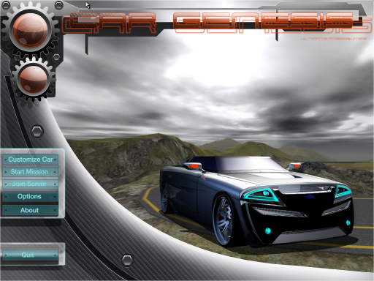
Main Menu

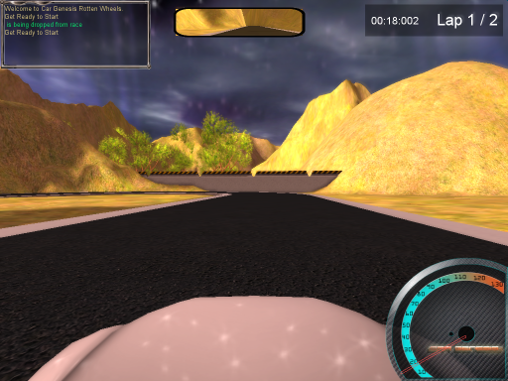
In-game interface (first person view)
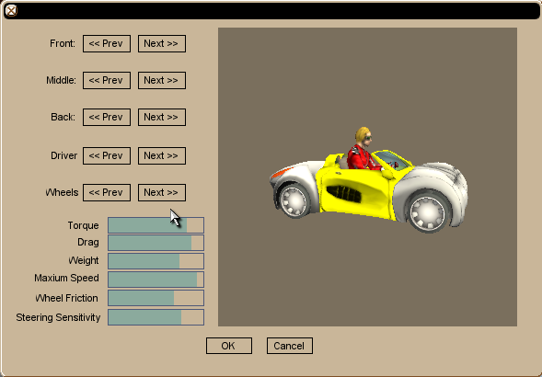
Car Customization Dialog
- Control Summary
- Keyboard
      - Accelerate – W or Up Arrow
      - Brake/Reverse – S or Down Arrow
      - Turn Left – A or Left Arrow
      - Turn Right – D or Right Arrow
      - Toggle 1st/3rd person view – tab
      - Handbrake - Space Bar
- Mouse
      - The car can be steered using the mouse by simply moving the mouse left or right. The distance the mouse is moved affects the magnitude of the steering move.
- Joystick
      - Y axis – Accelerate (forward) and Brake (backward).
      - X axis - Steer
- Racing Wheel & Pedals
      - Wheel – Steer
      - Pedals – Accelerate, Brake
- Game Controller
      - Although we were unable to test the game with a game controller, players should be able to use one to control their car. Torque treats game controllers as joysticks, so the same scripting that is used to handle joystick and racing wheel input should also support game controllers.
- Other
      - Any input device not mentioned here can still conceivably be used to control the car as long as it behaves similarly to one of the above input devices and identifies itself to Windows as one of those device types.
- Replaying and Saving
In single player mode, the player may choose to race on any track at any time and may replay any track as many times as he or she desires. Because there is no order in which the tracks must be completed, there is no need to save the player’s progress. In both single player and multiplayer mode, the player’s car configuration persists until he or she exists the game.

- Level Summary
- Desert Race
This track was designed as a somewhat short course that intermixed tight curves and small straightaways. It tests both the speed and handling of the vehicle.
- Dusk Race
This track was designed as a larger course than the desert track. Intermixed tight and wide curves, multiple level hills, along with larger stretches of straightaways allow the user to test the vehicle under more intensive and enduring circumstances.
- Motor Fairway
This track was designed as a large loop track. The straightaways are long and the curves are exceptionally wide to test the maximum speed of the vehicle.
- Artificial Intelligence
  - Opponent AI
There are no AI controlled opponents.
  - Player Detection
Checkpoints are placed around the track to ensure that players are following the correct path and to calculate when the player has finished a lap or finished the race. Each checkpoint has a trigger that detects when player has crossed the checkpoint.
  - Motion
Based on the parameters defined for each part and the car as a whole, the Torque game engine is able to simulate vehicle physics in a reasonably realistic manner.
  - Collisions
The base that the various car parts are attached to has an invisible mesh that encompasses itself and as well as the area that the other parts occupy. This is used by the game engine to detect collisions with objects and other players.
  - Combat
Car Genesis is intended to be solely about racing, so cars cannot become damaged and there is no direct combat. Despite the lack of direct combat, it is possible that players can utilize their entire car as a weapon by either attempting to drive in way that prevents opponents from passing or by deliberately ramming an opponent to force him or her to miss a checkpoint or to get out of the way.
- Game Elements
  - Items
    - Car Base
A model to which all of the parts are attached. It consists of little more than a simplified chassis, a seat and steering wheel, and mount points for other parts. The base is the same for all cars and does not affect the cars’ attributes.
    - Body Parts
A set of fronts, middles, and backs, each with unique attributes. The player selects one from each category and the sum of the part attributes helps determine the overall car attributes such as engine torque, mass, drag, and top speed.
    - Wheels
A set of wheels for the car. Different wheels produce different amounts of friction when they contact the ground as well as affecting the sensitivity of the car’s steering and its top speed.
  - Character Bible
    - Driver
A male or female driver which can be selected on the car customization screen. The driver has no name or backstory and does not affect the car’s performance in any way.
- Story Overview
  - Background/Plot Summary
All across the country, there exist elite groups of underground racers. Not content to simply perform basic customizations on their cars, they mix and match entire sections of existing vehicles and then test their creations by conducting time trials and ultimately pitting their creations against those of their peers in a race.
- Game Progression
  - Setting
    - The game takes at deserted “test tracks” whose locations are known only to the racers. These tracks are devoid of any vehicles besides the racers, allowing them to focus solely on winning.
  - Flowchart
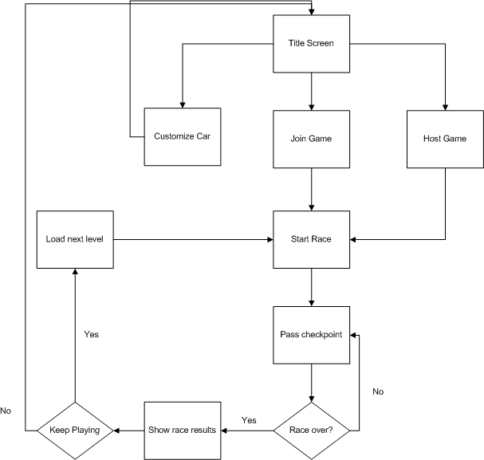
  - Level and Scene Details
    - Desert Race
A short, winding stretch of road in the middle of the desert with sharp turns, hills, and short straightaways.
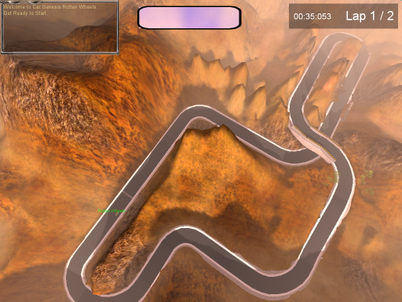
Aerial view of the “Desert Race” track.

    - Dusk Race
An evening race though the hills with a variety of different curve and some long straightaways.
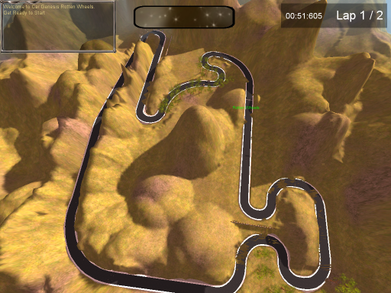
Aerial view of the “Dusk Race” track.

    - Motor Fairway
An abandoned speedway with exceptionally long straightaways and wide curves.
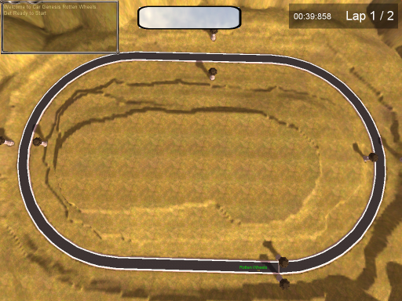
Aerial view of the “Motor Fairway” track.
- Bibliography
  - Both Versions
    - Cars, characters, and UI upgrades created by students from the College for Creative Studies.
    - Vehicle parameter adjustments by Hristo Petrov (CCS student).
    - The Game Programmer's Guide to Torque by Edward F. Maurina
    - “TGE 1.5.x - Bonus Resource Bundle” created by John Kabus -http://www.garagegames.com/index.php?sec=mg&mod=resource&page=view&qid=11518
    - “Vehicle Steering Upgrade” by James Jacoby - http://www.garagegames.com/index.php?sec=mg&mod=resource&page=view&qid=6305
    - Racing Wheel support by “Adios, Man!” - http://www.garagegames.com/mg/forums/result.thread.php?qt=24140 (private forum - requires SDK license to view).
    - Sound effects from “Sound Track Pro” by Apple, Inc.
  - High detail version
    - Torque Modernization Kit by Alex Scarborough - http://www.garagegames.com/blogs/44752/12441
    - TGE Shader Pack by Koushik Viswanathan - http://www.garagegames.com/index.php?sec=mg&mod=resource&page=view&qid=15662

